# **Lab: Group Policy**

## **Overview**

Systems administrations can use OUs (Organizational Units) and GPOs (Group Policy Objects) to apply computer configurations to specific departments or teams in the organization. Group policy can be used to protect user data by applying folder redirection to the Windows user files.

## **Scenario**

After a junior IT support technician accidentally deleted user data yesterday afternoon on a marketing executive’s computer, management at GlobeX wishes to know how you intend to backup user profile data on Windows 10 endpoints to prevent such incidents in the future.

## **Resources**

* [Group Policy Planning and Deployment Guide](https://docs.microsoft.com/en-us/previous-versions/windows/it-pro/windows-server-2008-R2-and-2008/cc754948(v=ws.10))
* [Back to Basics: Groups vs Organizational Units in Active Directory](http://techgenix.com/back-basics-groups-vs-organizational-units-active-directory/)

## **Objectives**

* Create a user
* Create an OU
* Create a GPO that redirects user’s Pictures folder to a shared folder on the Windows Server
* Validate the GPO works as expected to replicate a picture file to your Windows Server file share

## **Tasks**

### **Part 1: GPO Creation**

This part uses ADAC and GPMC.

* First you’ll need to create a file share on Windows Server that is accessible by the domain user on your Windows 10 endpoint.

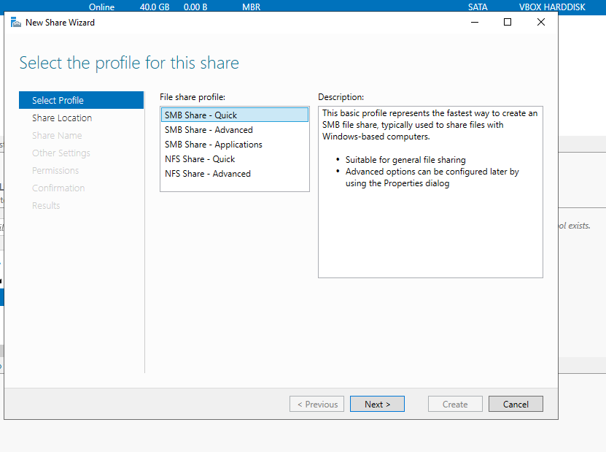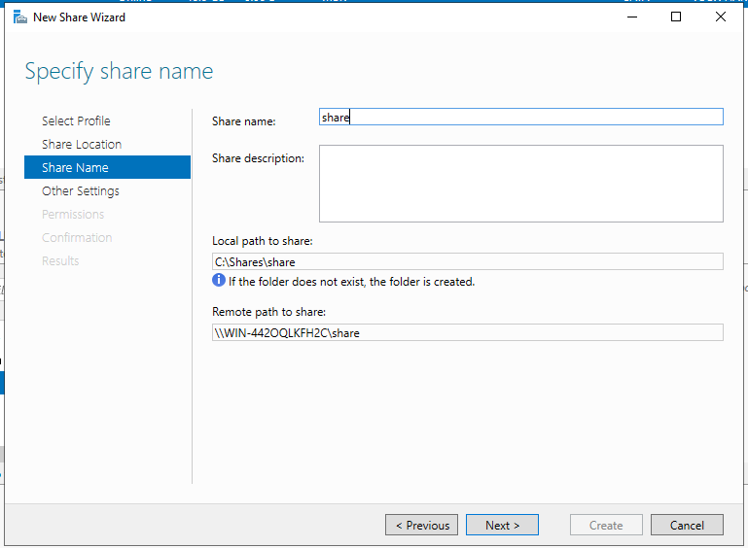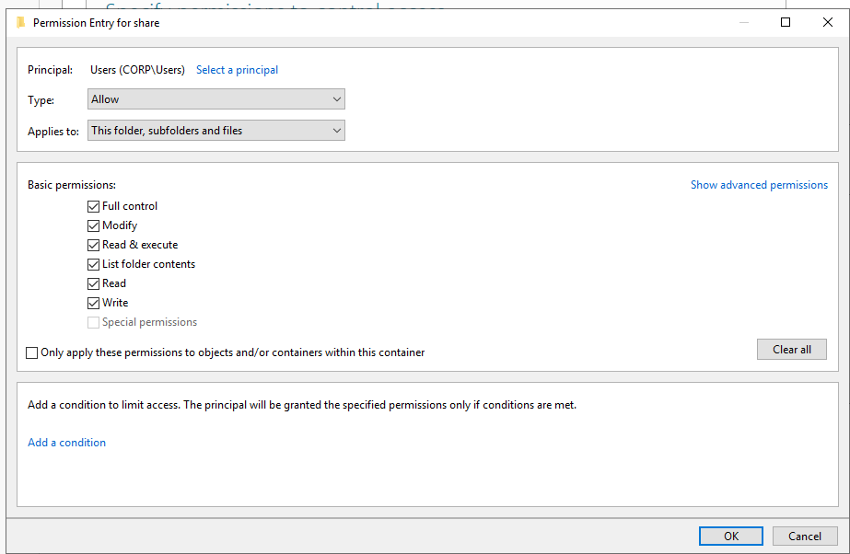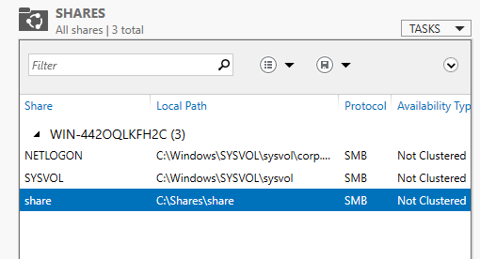

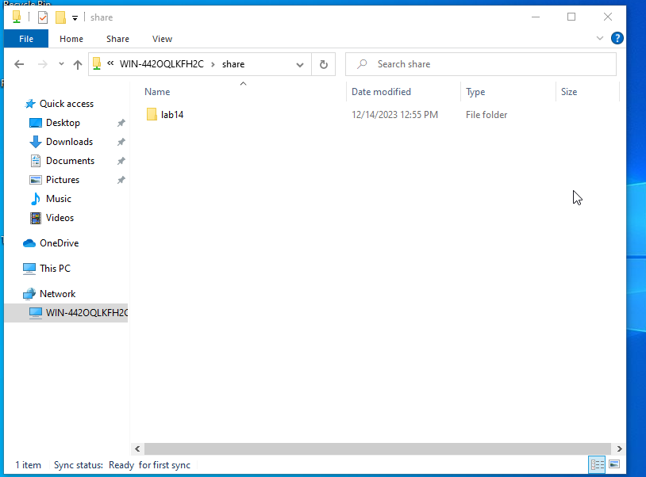

* + Don’t worry about security settings for now, but as a stretch goal you should lock this folder down to the user who needs it
* Create a domain user.

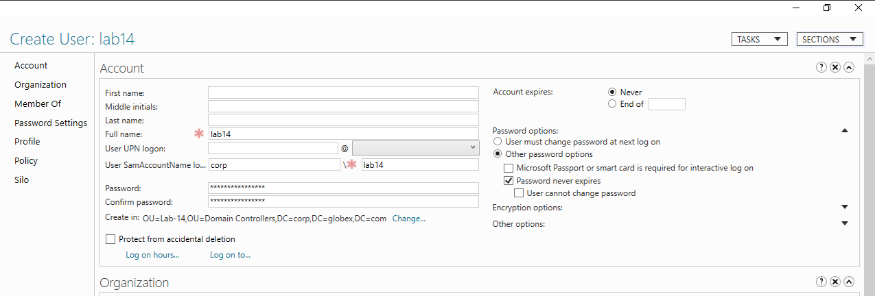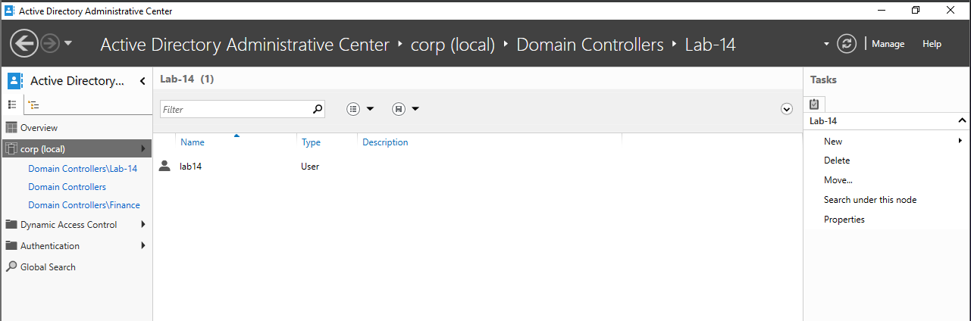

* Next create an OU that your domain user is affiliated with. This OU should be associated with the GPO you’re making next.

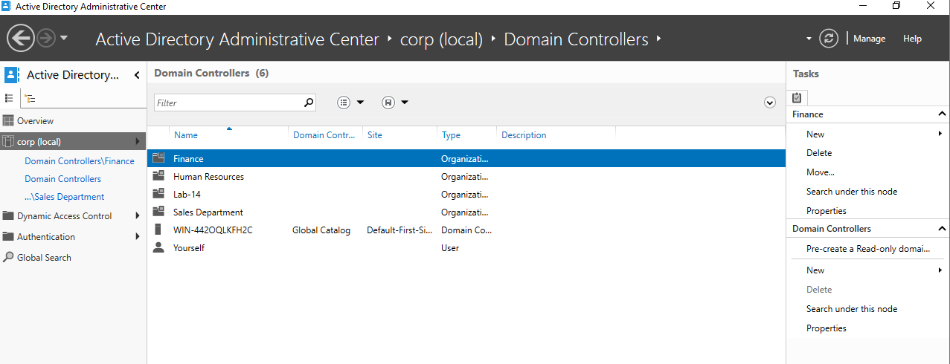

* Create a GPO that redirects user’s Pictures folder to a shared folder on the Windows Server.

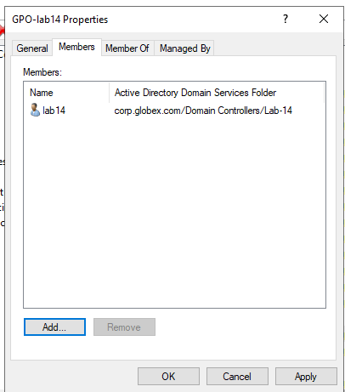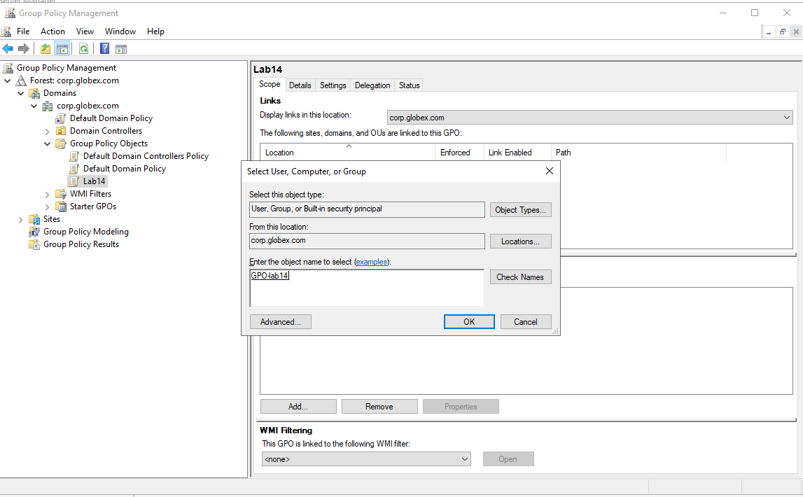

* Associate the policy with your the domain user account you want to apply it to.

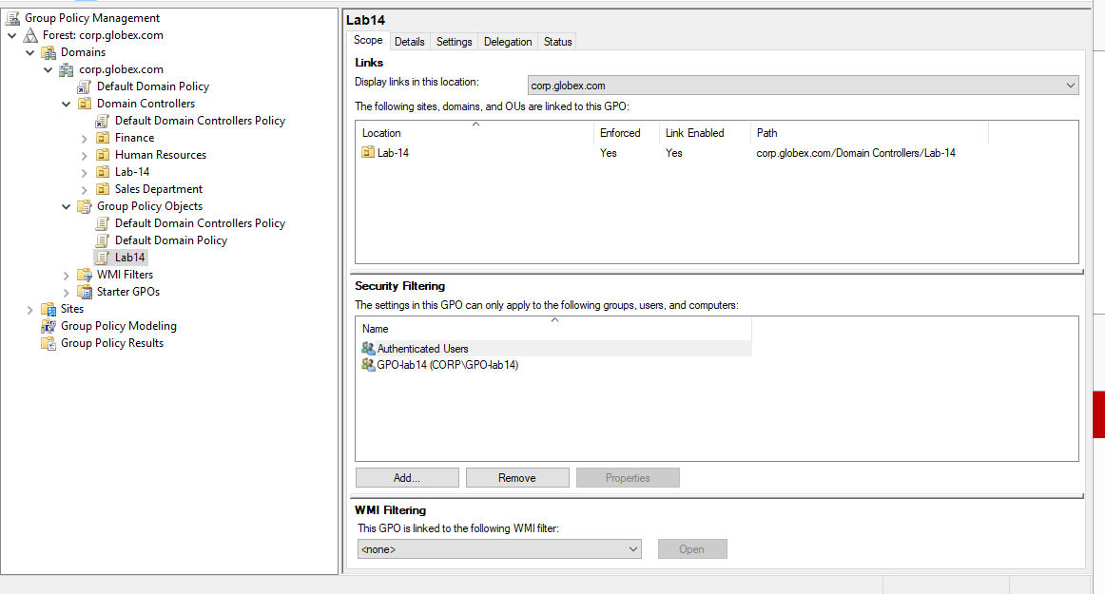

### **Part 2: Policy Push & Testing**

* Verify the folder redirection policy is effective by saving a picture to your Pictures folder and verifying it appears on the share in Windows Server.

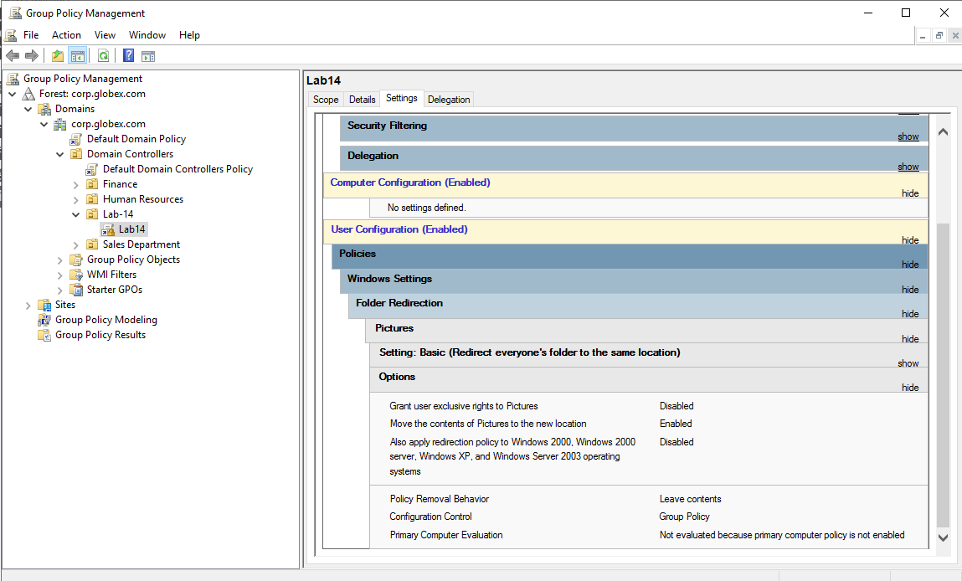

* + Remember how group policy is applied, and how you can force it to apply.

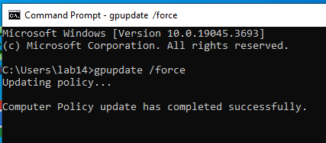

* + Some group policies only apply when the user logs in.

**I had no idea these screenshots were not inserted! As you can see, the share folder created the account for lab14, and inside the account folder are my pictures (which I accomplished on the 14th, like a good student).**



**You can see here that the picture folder is where it is supposed to be (both by the toolbar ‘Picture Tools’ and the icon for the directory location.**

